**Experiment Name:** LRU page Replacement Algorithm.

**Experiment No:** 10

**Objectives :** Learn about LRU page replacement algorithm . Emplement LRU page replacement algorithm by using c program. And testing the program different input and find output .

**LRU(Least Recently Used) Algorithm** : The Least Recently used (LRU) algorithm replaces the page that has not been used for the longest period of time. It is based on the observation that pages that have not been used for long time will probably remain unused for the longest time and are to be replaced.

**CODE:**

#include<stdio.h>

void main()

{

int q[20],p[50],c=0,c1,d,f,i,j,k=0,n,r,t,b[20],c2[20];

printf("Enter no of pages: ");

scanf("%d",&n);

printf("Enter the reference string:\n");

for(i=0; i<n; i++)

scanf("%d",&p[i]);

printf("Enter no of frames:\n");

scanf("%d",&f);

q[k]=p[k];

printf("\n\t%d\n",q[k]);

c++;

k++;

for(i=1; i<n; i++)

{

c1=0;

for(j=0; j<f; j++)

{

if(p[i]!=q[j])

c1++;

}

if(c1==f)

{ c++;

if(k<f)

{

q[k]=p[i];

k++;

for(j=0; j<k; j++)

printf("\t%d",q[j]);

printf("\n");

}

else

{

for(r=0; r<f; r++)

{

c2[r]=0;

for(j=i-1; j<n; j--)

{

if(q[r]!=p[j])

c2[r]++;

else

break;

}

}

for(r=0; r<f; r++)

b[r]=c2[r];

for(r=0; r<f; r++)

{

for(j=r; j<f; j++)

{

if(b[r]<b[j])

{

t=b[r];

b[r]=b[j];

b[j]=t;

}

}

}

for(r=0; r<f; r++)

{ if(c2[r]==b[0])

q[r]=p[i];

printf("\t%d",q[r]);

}

printf("\n");

}

}

}

printf("\nNo page faults is %d \n",c);

}

**Output**:

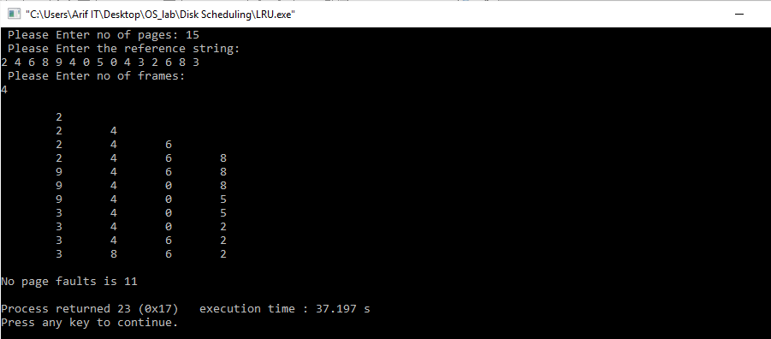

**Conclusion:**

After doing this lab report we learn about LRU page replacement algorithm. We also learn how to implement LRU page replacement by using C program And testing the program different input and find output.